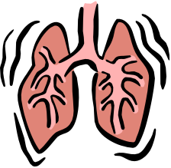
Measuring Lung Capacity

Lung capacity is the amount of air your lungs can hold. Good lung capacity is helpful in competitive sports. In this activity you will be measuring the vital capacity and the tidal volume of your lungs.
- TIDAL VOLUME is the amount of air that you move in and out of your lungs while breathing normally.
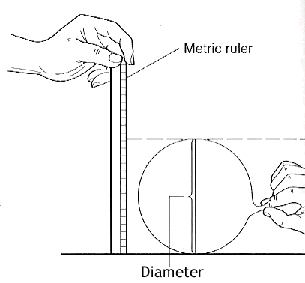
- VITAL CAPACITY is the maximum amount of air moved in and out of the lungs.

Materials:
- Balloons
- Metric ruler

Measuring Tidal Volume
- Stretch a round balloon several times.
- Inhale normally and then exhale normally into the balloon. Do not force your breathing.
- Pinch the end of the balloon and measure its diameter.
- Repeat this so that you have 3 measurements.
- Record the measurements on the data table.
- Find the average of the measurements.

 | Diameter 1 | Diameter 2 | Diameter 3 | Average Diameter
Person 1
Person 2
Person 3

Measuring Vital Capacity
- Repeat the procedure, only this time inhale as much air as you can and exhale forcefully into the balloon.
- Record three measurements in the data table.

 | Diameter 1 | Diameter 2 | Diameter 3 | Average Diameter
Person 1
Person 2
Person 3
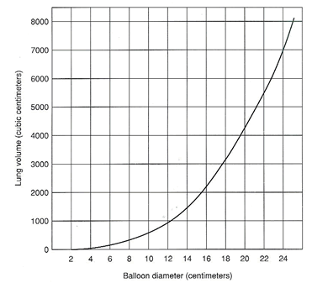
Questions:
- Convert the average diameters to a volume using the graph. Add an appropriate heading to the table and record this in your table.

- Explain the difference between tidal volume and vital capacity.

- What variables might affect a person’s lung capacity?

- Compare your data with the other people in the group.
  - Is there a difference between each person’s tidal volume? Explain why or why not.

  - Is there a difference between each person’s vital capacity? Explain why or why not.

- How might an athlete’s vital capacity compare to a non-athlete’s vital capacity? Explain your reasoning.

